Login Instructions
Halogen uses a single-sign-on type of user access.

HSHS Colleague Login Within the HSHS Network
Select the top blue button to login. Halogen will automatically authenticate the HSHS Colleague’s organizational/network login credentials and automatically log the user in without entry of a username or password.

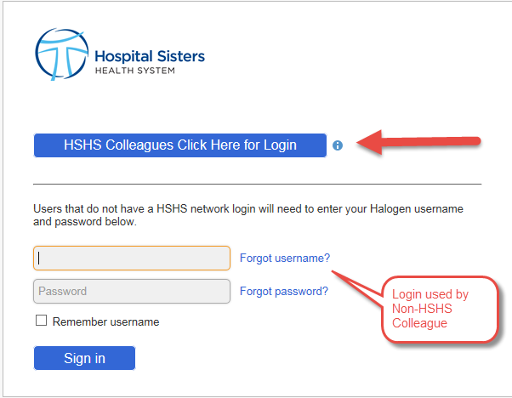

Accessing Halogen Outside of the HSHS Network

- Enter this Halogen URL in the Internet browser: https://global.hgncloud.com/hshs/welcome.jsp
- Select the top login button.
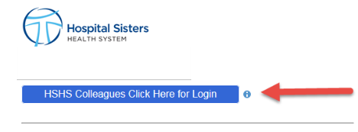

- A window will prompt the user to login with their network domain\username and password. The colleague will then be automatically logged into Halogen without entry of any additional login information.
